**Assignment -1**

|  |  |
| --- | --- |
| Assignment Date | 19 September 2022 |
| Student Name | Dhivanesh M.R |
| Student Roll Number | 111519106027 |
| Maximum Marks | 2 Marks |

**Question:**

Build a smart home in Thinkercad with 2 sensors, an Led, buzzer and submit it.

**Solution:**

CIRCUIT DIAGRAM:

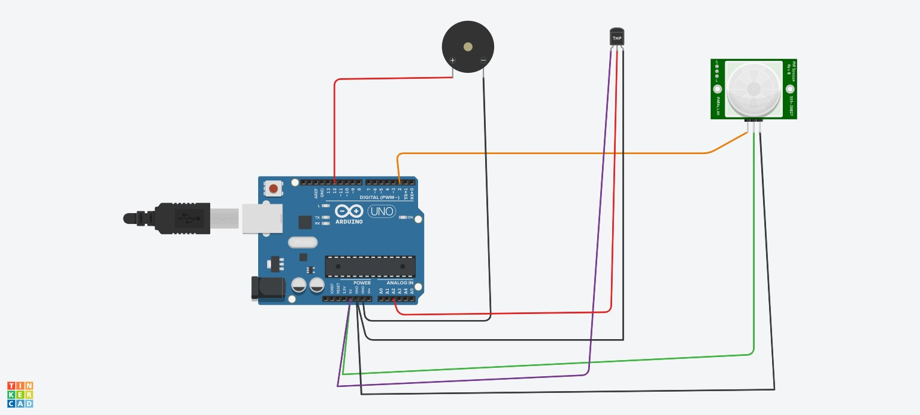

SCHEMATIC DIAGRAM:

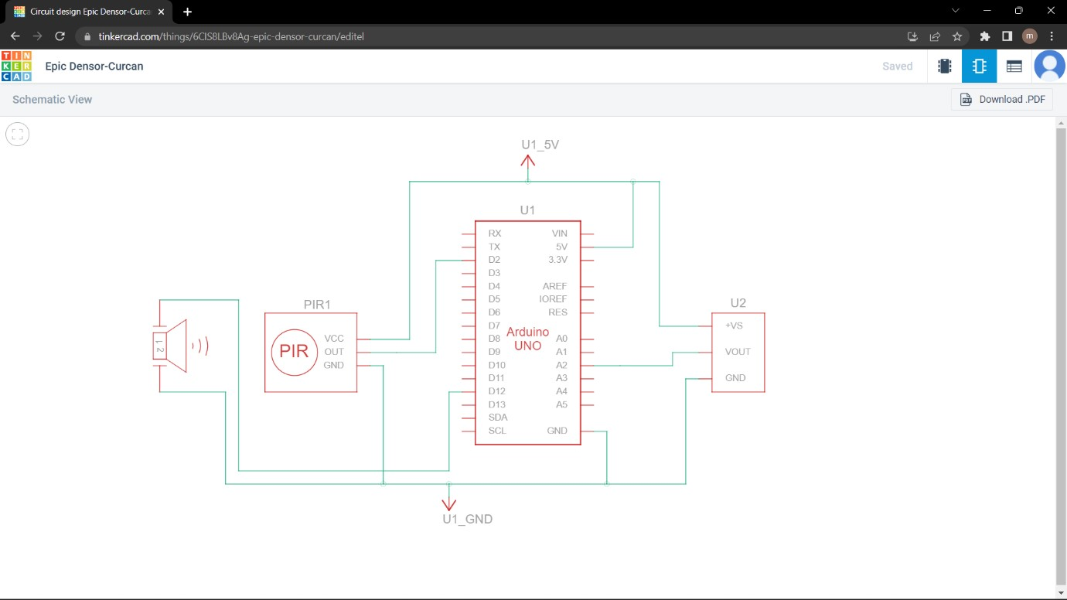

Code:

// C++ code

// void setup()

{ Serial.begin(9600); pinMode(2, INPUT); pinMode(12, OUTPUT);

}

void loop()

{

intmotion=digitalRead(2); if(motion==1)

{

Serial.println("Motion is Detected !"); tone(12,10); delay(1000);

noTone(12); delay(3000);

} else

{

Serial.println("No Motion!!!"); delay(1000);

}

double data=analogRead(A2); double n=data/1024; double voltage=n*5; double offsetvol=voltage-0.5; double temp=offsetvol*100; if(temp>60)

{

Serial.println("Temperature higher than 60 degrees !!"); Serial.println(temp); tone(12,10); delay(1000); noTone(12);

delay(3000);

} else

{

Serial.println("Temperature lesser than 60 degrees !!"); Serial.println(temp); delay(1000);

}

}